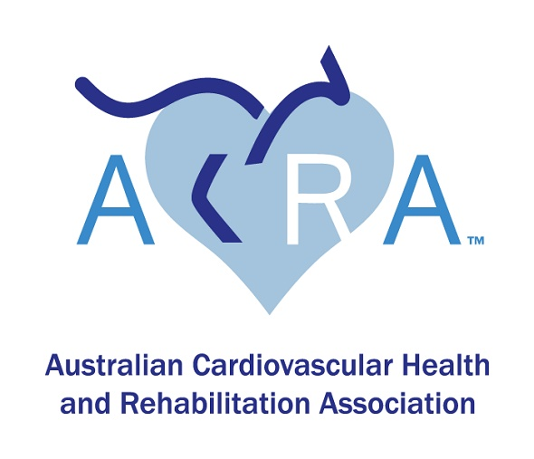

**The Australian Cardiovascular Health and Rehabilitation Association (ACRA)**

**Annual Scientific Meeting (ASM) Anna Storen Regional Travel Award**

*This award honours the work and contribution of Anna Storen who died in 2021 after a long battle with cancer. Anna was a dedicated cardiac rehabilitation nurse for 12 years working for the North West Regional hospital in Burnie, Tasmania. During this time, she was a committee member of ACRA, with 3 years on the state committee, including 2 years as Vice President, contributing to state-based education events and 2 years on the national Executive Management Committee (EMC) representing Tasmania. During her time on the EMC, she contributed to the Membership subcommittee, working hard to encourage ACRA membership amongst Tasmanian cardiac rehabilitation clinicians. She also contributed to the Corporate and Finance and ACRA national survey subcommittees.*

Applications are called for the ACRA Anna Storen Regional Travel Award to enable regional and remote ACRA members to attend the 34th ACRA Annual Scientific Meeting (ASM) at the Hotel Grand Chancellor, Brisbane.

The award is intended to further develop the successful candidate through increasing their clinical knowledge and expertise, awareness of research and evidence-based practice and will also allow the successful candidate to extend their professional network. In particular, this strategy enables clinicians from regional areas to experience a conference and its education, networking and research benefits.

**Applicants for this award are required to work in an area outside the city where the ASM is being held for that year or 50 km or more from that city’s airport. Preference is given to those working in a rural or remote area. Applicants are also encouraged (but not required) to have an abstract, under one of the many categories, accepted for presentation.**

**The award:**

Valued at $1000, the recipient will receive support to assist in defraying the cost of travel, accommodation and registration.

**Selection criteria:**

1. The applicant must be a currently financial member of ACRA for at least 12 months (prior to the close of applications).
2. Working or studying in a clinical area of cardiac rehabilitation, cardiology or cardiothoracic surgery or working in an area where there is a large caseload of patients with cardiac conditions.
3. Applicants must reside outside of the city or region in which the ASM is being held.

**How to apply:**

* The applicant should submit a 300–500-word document describing their interest in cardiovascular health and stating, with clear emphasis, the benefits to their clinical practice /patients that attending the conference will provide. For example, how will it add to the applicant’s career development, how it will benefit their workplace and how the applicant can contribute to ACRA.
* Applicants should include details of their area of clinical work or study, including patient caseload and patient cardiac conditions.
* The successful candidate will be required to contribute a 500-word summary outlining how they have benefited from the conference and how they have disseminated their learnings to their work place colleagues. This piece will then be displayed on the ACRA website and in the newsletter to encourage future applications.

Applications open on March 10th 2025 and close on **May 10th 2025**

Please submit your applications to either

[acra2025asm@gmail.com](mailto:acra2025asm@gmail.com)

or

ACRA Secretariat [admin@acra.net.au](mailto:admin@acra.net.au)