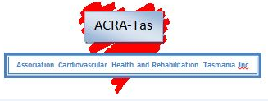

DIRECTORY OF TASMANIAN

CARDIAC REHABILITATION

PROGRAMS

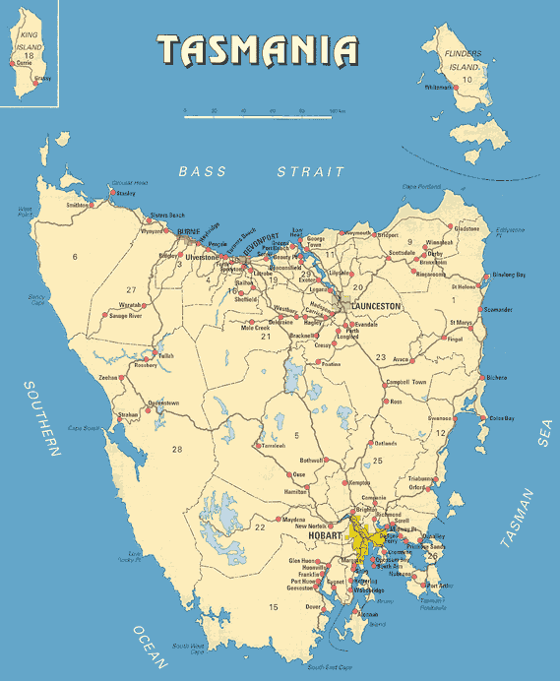

For further information or updates please contact:
Sue Sanderson
03 6166 7398
0421 601 462
Email : sue.sanderson@ths.tas.gov.au

INDEX
LOCATION GUIDE
BURNIE North West Regional Hospital 3
LATROBE Mersey Community Hospital 3
HOBART Royal Hobart Hospital 4
HOBART Integrated Care Centre, Clarence 4
LAUNCESTON Northern Integrated Care Service 5
COACH Statewide 6

ROYAL FLYING DOCTOR SERVICE 6

CARDIHAB Statewide 7

BURNIE
North West Regional Hospital Burnie campus
23 Brickport Road, Burnie TAS 7320
03 6430 6644
03 6430 6693

Outpatient Program
Coordinator: Teresa Ainsworth
0409 503 547
Email : cardiacrehabnwrh@ths.tas.gov.au
Comment: 9-week rolling program held off-site at the McKenna Park Hockey complex. Education and exercise sessions conducted weekly, on a Thursday from 12:30 to 3pm. Patient assessment pre- and post-program.

Patients: All patients who have a cardiac condition, medical and surgical, are all invited to attend. If possible, we also include anyone who requires life-style changes for prevention of disease

Cardihab - Digital Cardiac Rehabilitation via SmartCR App

LATROBE
North West Regional Hospital Mersey campus
PO Box 21, Latrobe TAS 7307
03 6478 5364
0409 973 216
Outpatient Program
Coordinator: Sonya McQueen and Erin Webb
Email: mch.cardiacrehab@ths.tas.gov.au
Comment: 7-week education & exercise program
Support at CR clinic for unsuitable class participants

Patients: AMI, PTCA/PCI, Post cardiac surgery and their carers, pacemaker/ICD, angina, cardiac risk factors for prevention and class one and two heart failure.

Sessions: Face to face consultations Mon-Wed mornings
Thursday between 1000 – 1200hrs and include Graded Exercise, Dietary Advice, Cardiac Risk Factors, Lifestyle Management, Cardiac Medication, Stress and Relaxation

Cardihab - Digital Cardiac Rehabilitation via SmartCR App

HOBART
Royal Hobart Hospital
48 Liverpool Street Hobart TAS 7000
03 6166 8572
03 6234 2852
Outpatient Program
Coordinator: Judy Enright
Email: judith.enright@ths.tas.gov.au
03 6166 8914
Mobile: 0439 682 601
CRN: Beth Crouch / Amanda Bowes / Missy Thomas / Amy Lowe
03 6166 8914
0429 462 831
0457 170 773
03 6234 2852
Email: rhh.cardiacrehab@ths.tas.gov.au

Cardihab program – Digital Cardiac Rehabilitation via SmartCR App - 6 week supported program; weekly telephone assessments

Patients: patients with a cardiac diagnosis unable to attend or complete a centre-based program

Clarence Integrated Care Centre
Bayfield St Rosny Park 7000
03 6282 0300
Outpatient Program
Coordinator: Judy Enright (CNC)
Email: rhh.cardiacrehab@ths.tas.gov.au
03 6166 8914
0439 682 601
03 6234 2852

Comment: 6 weeks rolling program, delivered by cardiac rehabilitation nurses, and includes exercise and education and a pre- and post-rehab assessment. Sessions include risk factors and symptom management; exercise benefits, principles, potential barriers; healthy eating; psychosocial aspects of heart disease; know your medications; return to and maintenance of a healthy lifestyle.

Sessions: Tuesday, Wednesday 1.00-3.00pm
Patients: ACS, PCI (including elective), post cardiac surgery, stable heart failure (NHYA I and II), and their carers. Numbers are currently limited due to COVID restrictions.

LAUNCESTON
Northern Integrated Care Service
41 Frankland Street, LAUNCESTON TAS 7250
1300 977 518 or 03 6777 4145
03 6777 5247
Email: nics.admin@ths.tas.gov.au
Outpatient Program
Cardiac Health and Rehabilitation Nurse: John Aitken
Email : john.aitken@ths.tas.gov.au
03 6777 6472
0400 433 527
Comment: 8-week rolling program of education and supervised exercise.
Patients: AMI, PCI, post-surgery, heart failure; all patients with a cardiac condition.

Sessions: Two classes Wednesday and Thursday 0930-1230. Sessions include Risk factors and symptom management; exercise benefits, healthy eating; psychosocial aspects of heart disease; know your medications.

Telephone supported home-based program also available.

Nurse Led consultations: Monday, Tuesday, and Friday.
Program consultations: Wednesday and Thursday afternoons and Fridays.

Cardihab - Digital Cardiac Rehabilitation via SmartCR App

COACH Program© – Diabetes Tasmania
Telephone coaching for your heart health

Level 7, 152 Macquarie St, Hobart.
03 6215 9000 (Hobart)
03 6215 9099
Email: mail@diabetestas.org.au
Free telephone coaching program for people with or at high risk of chronic disease and for those who have heart disease.

It is a structured telephone health coaching program targeting improvement in the known risk factors for cardiovascular disease and is delivered by trained health professionals.

Monthly telephone calls over a 6-month period supporting long term maintenance change including healthy eating, physical activity, smoking and medication adherence.

After-hours appointments are available.

Patients: at risk of heart disease, have heart disease – heart attack, stent, surgery
03 6215 9000 (Hobart)
03 6333 0233 (Launceston)

ROYAL FLYING DOCTOR SERVICE
Prime Mover Programs
Locations: Flinders Island, George Town LGA, Dorset LGA, Break O’Day LGA, Glamorgan Spring Bay LGA, Bruny Island, Tasman Peninsula LGA, Huon Valley LGA

0455 440 551
Email : referrals@rfdstas.org.au

Prime Mover – Phase III Cardiopulmonary Rehabilitation Community Program
Physical and Rural Health Team Leader: Joyce Tan AEP

Patients: patients with cardiovascular disease and/or chronic obstructive pulmonary disease

Initial assessment visit: comprehensive assessment, management plan, brief education (1 – 1 ½ hours)

Cardiopulmonary rehabilitation: Supervised exercise sessions, hourly, twice weekly for 8 weeks. Education with self-management skills development incorporated into exercise session according to individual needs for the duration of the program.

Exit Assessment: A review assessment is arranged at the completion of the program to provide feedback and ongoing management which consists of either extended home- based program or additional support through group sessions depending on need.

1:1 home-based program also available for clients unable to access group sessions

Cardihab - Digital Cardiac Rehabilitation via SmartCR App

CARDIHAB – Smart CR
Digital remote Cardiac Rehabilitation
Email: info@cardihab.com
Website: www.cardihab.com
Supported by the THS and RFDS, Cardihab is available state-wide.
Digital Cardiac Rehab is delivered over 6 – 10 weeks via a smartphone or tablet device using SmartCR or RFDS Prime Mover apps enabling patients to connect with their clinician.

Enabling clinicians to review patient reported activity between consults. Cardihab is an individualised program with Initial and Final assessments and weekly clinician telephone consults.

Educational support
Education addresses all aspects of cardiovascular health such as risk factors and symptom management to assist with patient recovery. With on demand videos and links to online evidence-based documents for further reading relevant to the individual patient.

Care plan activities
Patients receive daily prompts and can record and track activity (steps, exercise, walking), medications, blood pressure and others.
Guided relaxation audio for stress management.
Patients can continue to use the app for 12 months to self-manage healthy heart lifestyle.

Contact: Cardiac rehabilitation staff at THS hospital closest to patient’s home or Royal Flying Doctor Service (0455 440 551)

